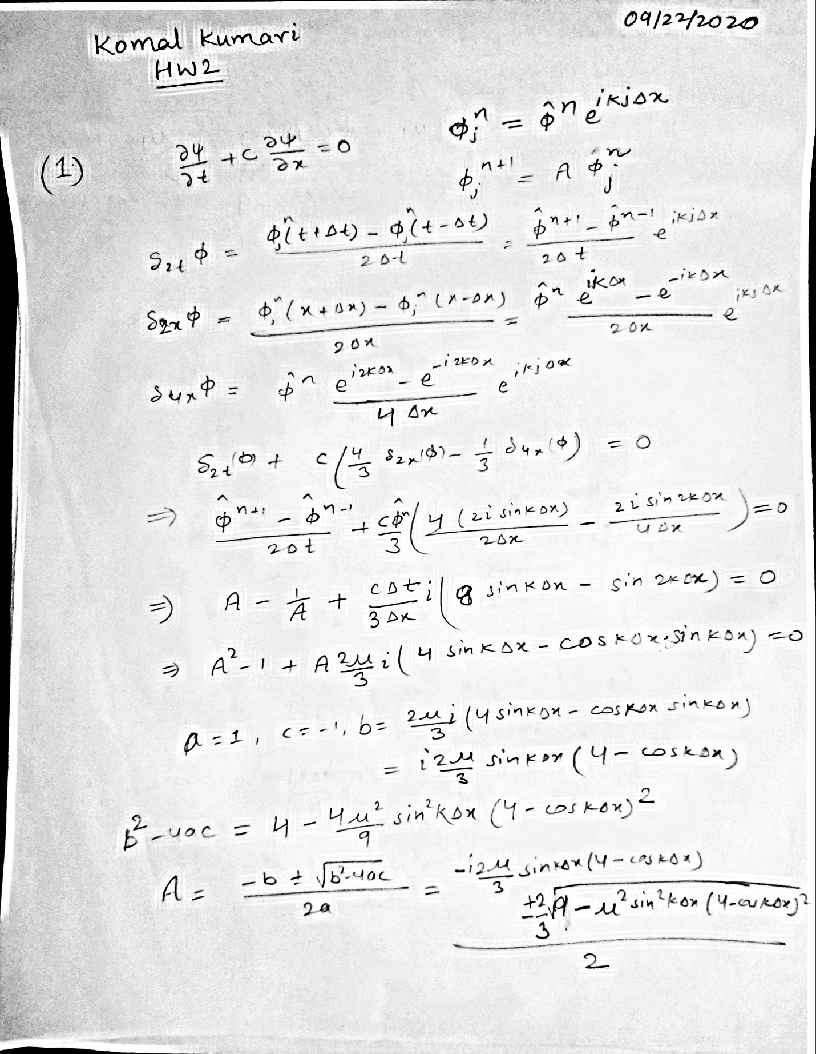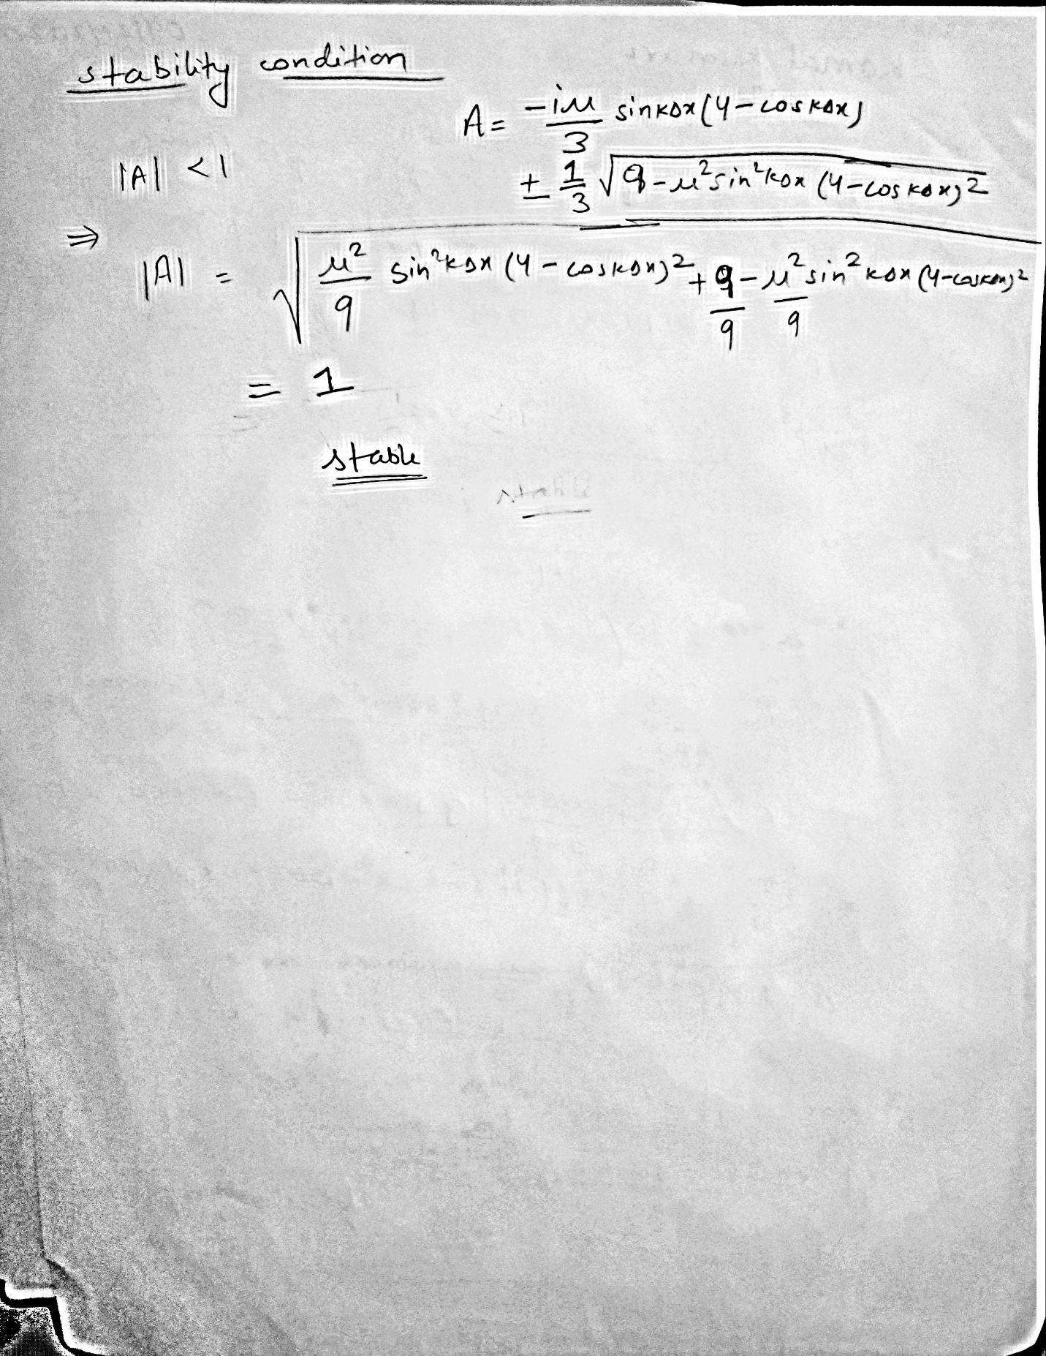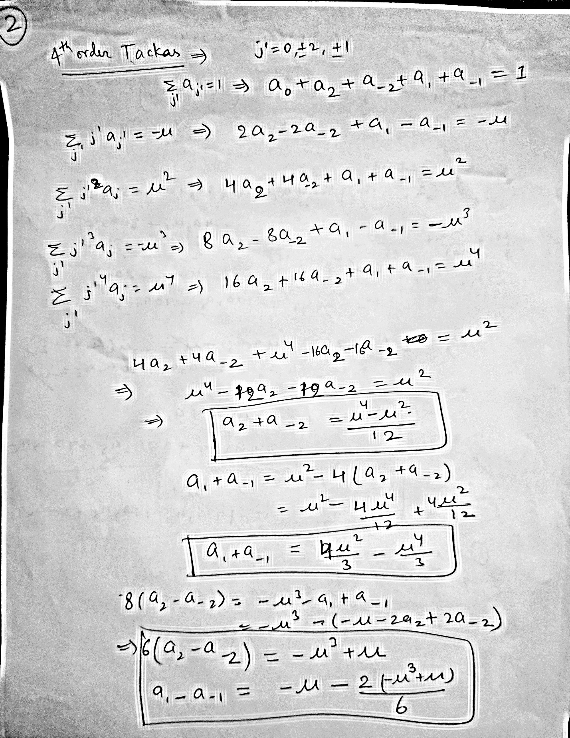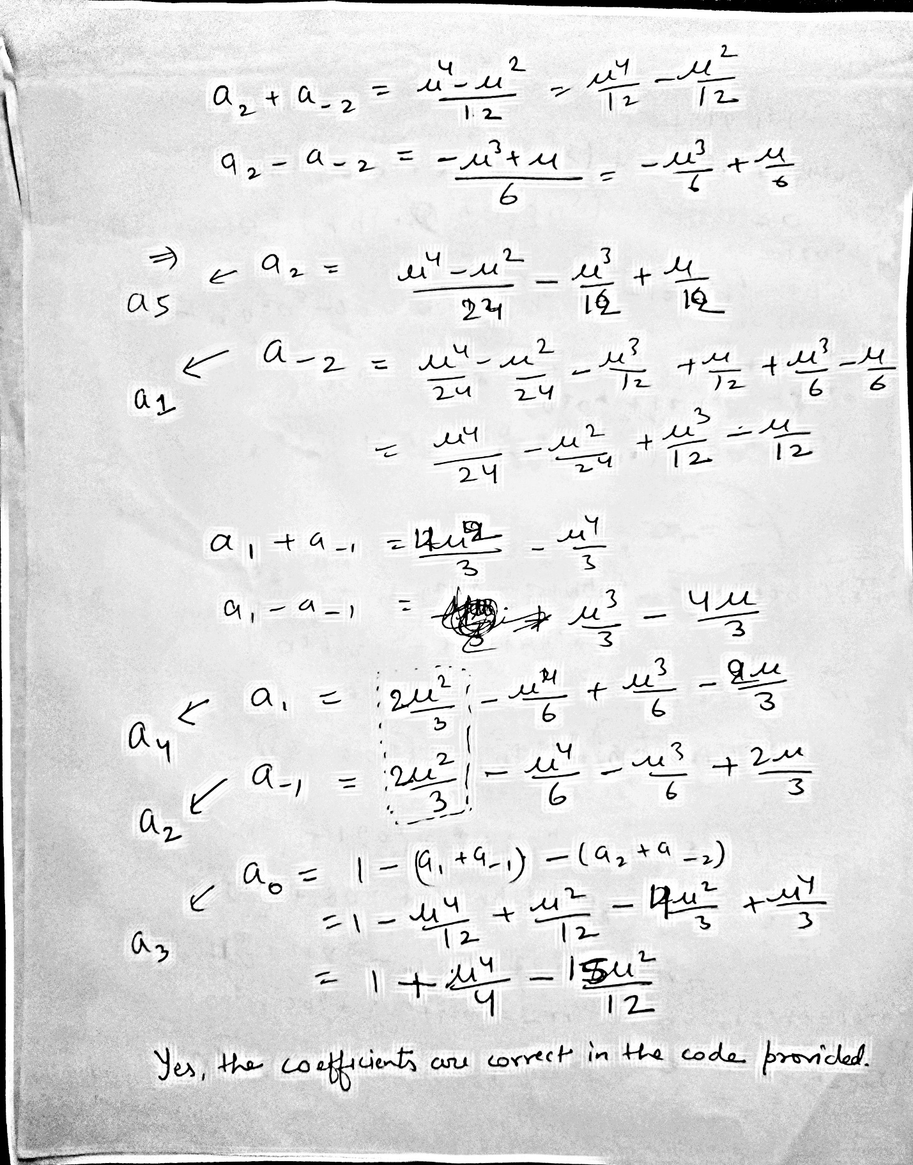

3. 1&2) In both cases (single wave component & two-wave component), using 4th order Takacs and RK4 scheme, the maximum amplitude matches well with true value. However, using LaxWen and Takacs-3rd order scheme, the amplitude seems damped than true value for smaller CFL values <0.5. When CFL value ~1.0 then, LaxWen and Takacs-3rd and 4th order scheme agrees well with true values. For CFL>1.0 then LaxWen scheme gives unstable solution. There is significant phase shift for RK4 method and also in LaxWen scheme for smaller CFL number. When, CFL~1.0, the solution agrees well with true solution using LaxWen scheme.

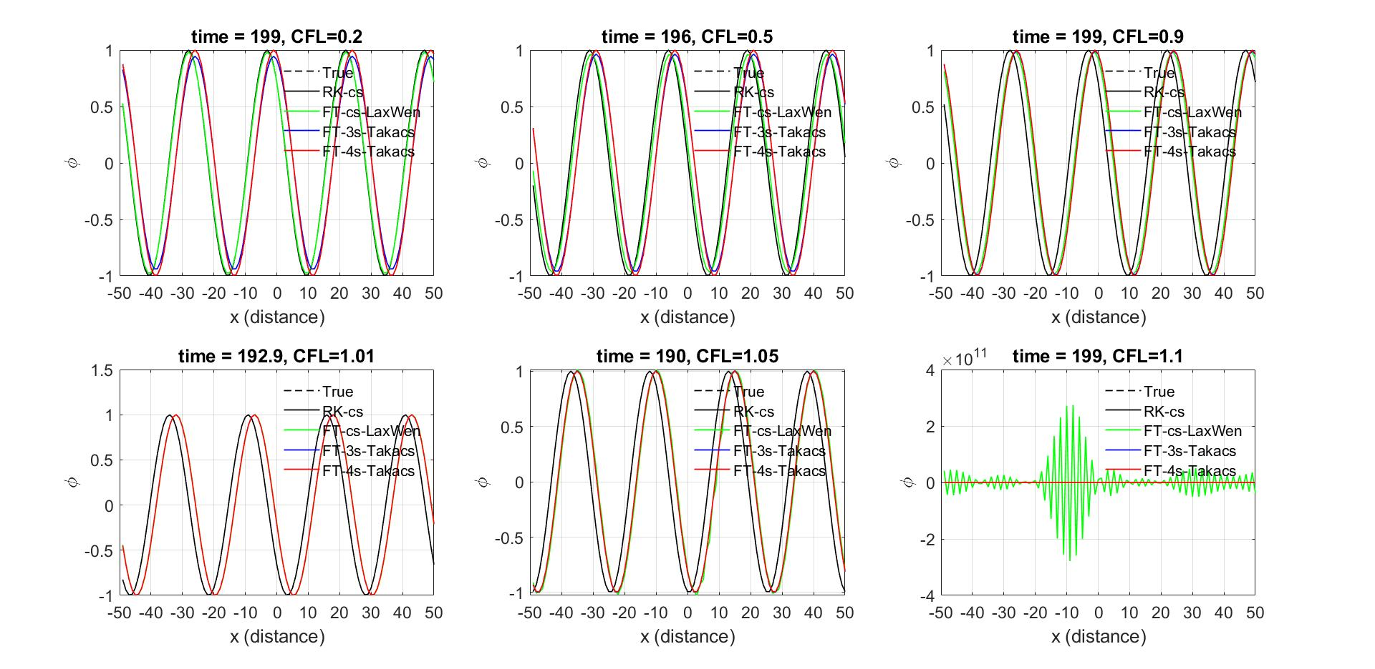

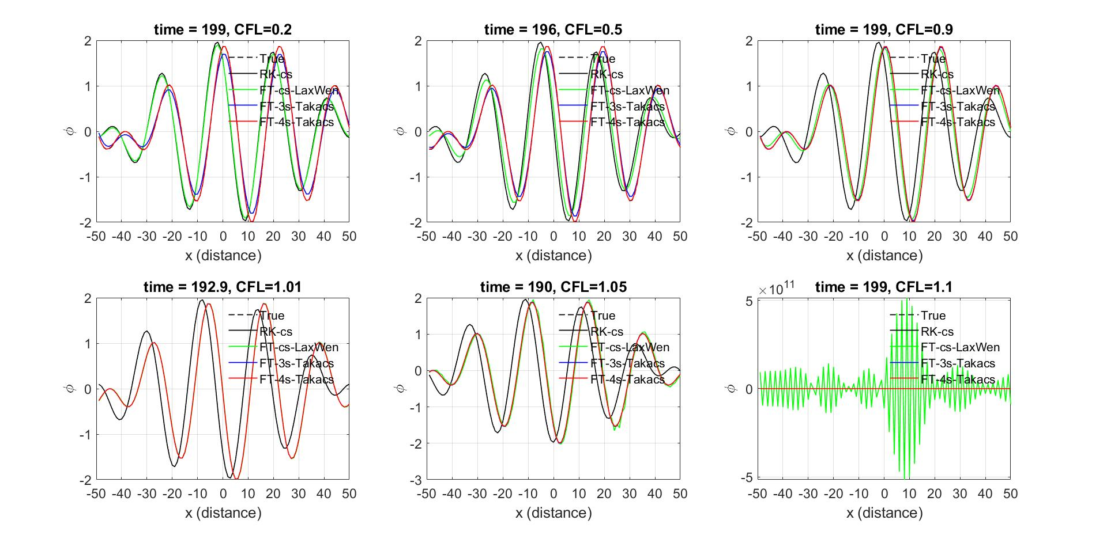

3. 3) Here, for the square waveform modeling, the Takacs-3rd order scheme performs better than 4th order, perhaps due to amplitude error being bigger than phase error. However, for the triangular waveform modeling, Takacs-4th order is closer to true value than the Takacs-3rd order. This is due to the fact that the amplitude error in Takacs-3rd order is bigger than Takacs-4th order. That might cause damped amplitude for triangular waveform using Takacs-3rd order scheme while Takacs-4th order provides smaller amplitude error as well as less phase dispersion. Note that RK4 and LaxWen scheme for both waveforms seem to have considerable dispersion error. In both square and triangular waveform cases, the CFL>1.0 gives instability condition for LaxWen scheme. While at CFL ~1, it gives less amplitude and phase error for both LaxWen and Takacs scheme.

